### **Clean Water, Bright Futures**

*—How ASK turned thirsty classrooms into places of promise—*

Water is a small word but a mighty bridge: it carries children from sickness to strength, from weariness to wonder. In rural Tamil Nadu, **Arsha Seva Kendram (ASK)** has been building that bridge—one pipeline, one desk, one smile at a time.

#### **1. Padanda Puli High School**

Before: salty water that tasted of rust and risk.  
 Now: an overhead tank and an RO filter pouring **30 litres every hour**—enough for every throat and then some. The pipes snake through campus like silver vines, and the taps bloom with clear water.

Bonus: **20 shiny desks and benches** plus **two rolling blackboards**. Children who once wrote on their knees now sit tall, pencils dancing like fireflies.

#### **2. Parnandabali Primary School**

Fifty-five little learners used to lug bottles from home. One RO unit later, they sip safely and spend saved energy on sums and songs.  
 *Followed by the inauguration, the headmaster and teachers had organised a cultural program—singing, Thirukkural recitation, etc. We also encouraged the students to participate in a Thirukkural recitation. The program concluded with the distribution of sweets and tea to the students, followed by a prayer.*

#### **3. Idaiseval Middle School**

At **105 students**, it’s the biggest pond in our pie. A new purifier means fewer sick days and more report-card victories.

#### **4. Meithalaivanpatti Primary**

**39 students**; one bright tank on stilts; one RO system checked like clockwork. Their laughter now rings cleaner than the water itself.

#### **5. Villiseri Primary**

A tank once left unwashed for four long years is reborn. **35 students** drink without fear, and the old rust stories fade like chalk in rain.

#### **6. Nachiyarpuram Primary**

Clean water arrived first; toilets are rising next. **35 children** trade open fields for safe stalls—and gratitude flows as freely as the taps.

#### **7. Sattirapatty Primary**

**34 youngsters** on the outer rim of Kovilpatti. Buses are scarce, but water is sure: a brand-new RO unit stands guard until better transport joins the rescue.

#### **8. Gopalapuram Primary**

Water today, **four desk sets** on the way. No more floor-math; soon every child will count from a proper seat.

### **The Numbers at a Glance**

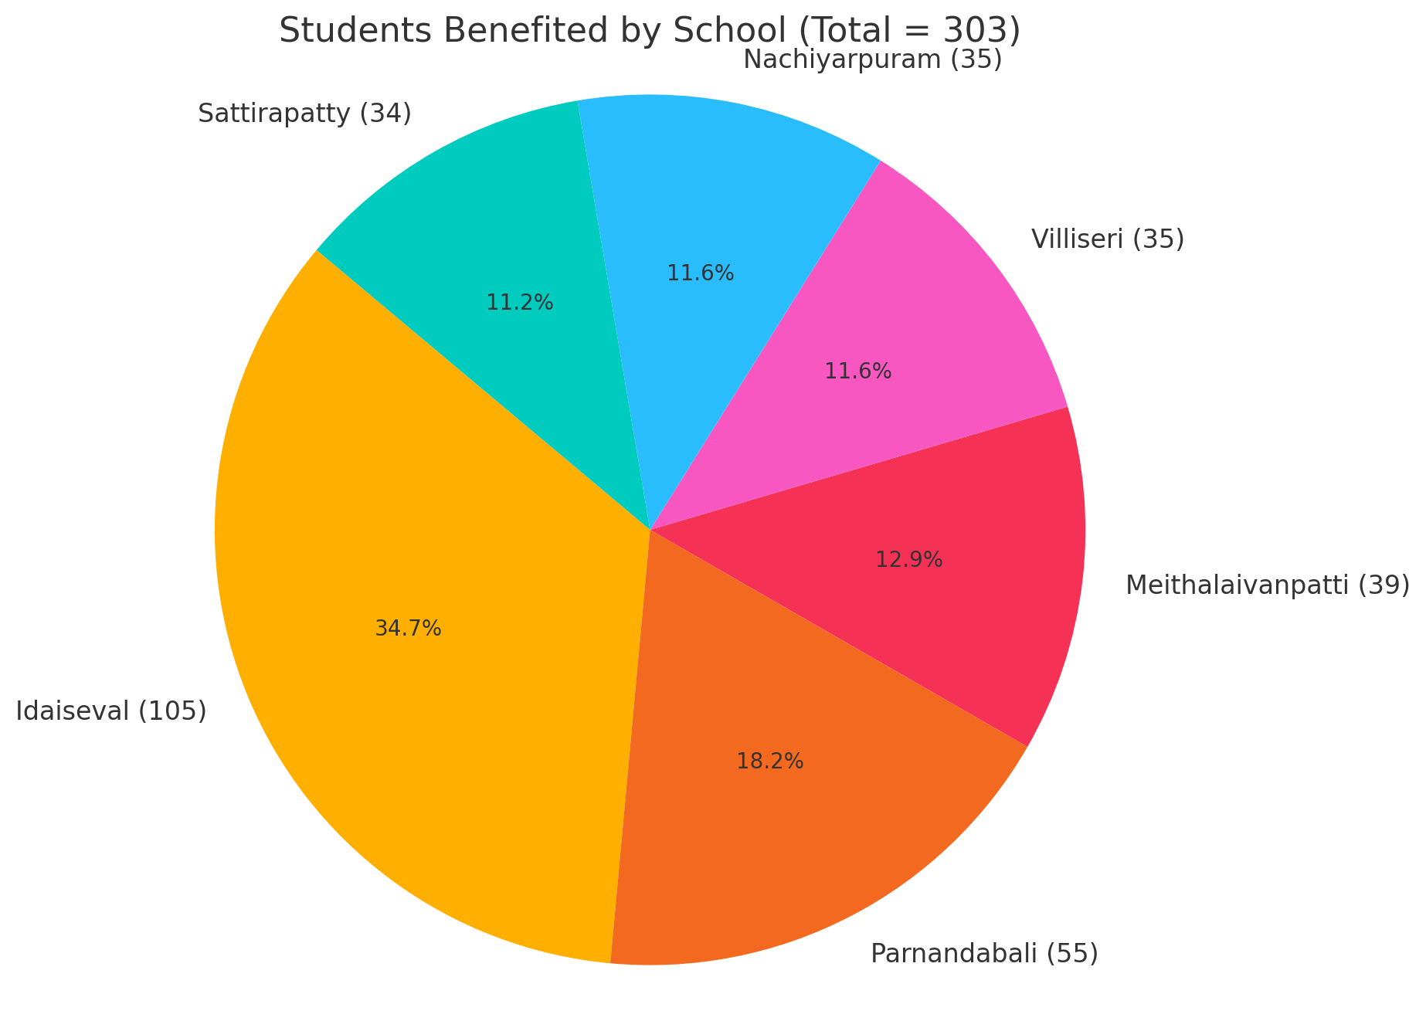

(See the pie chart above: **303 students** now drink clean water across six of these schools, with Idaiseval holding the largest slice.)

### **Why It Matters**

* **Health:** Fewer stomach aches, more classroom days.
* **Dignity:** From crouching on floors to sitting like scholars.
* **Hope:** When water is safe and seats are steady, the mind can leap farther.

### 

### 

### **A Simple Equation**

*Pipes + Purifiers + Benches = Stronger Students*

ASK’s work is not fancy engineering; it is everyday magic. Each tank is a wellspring, each desk a launch-pad. Together, they turn “just another village school” into a workshop of dreams.

### **Closing Image**

Picture a small girl in Padanda Puli. She lifts a metal tumbler; water glints like liquid sunlight. She drinks, wipes her mouth, slides onto a new steel bench, and opens a fresh notebook. On that blank page waits the first line of a future that is now a little cleaner, a little brighter—thanks to the quiet roar of ASK.

